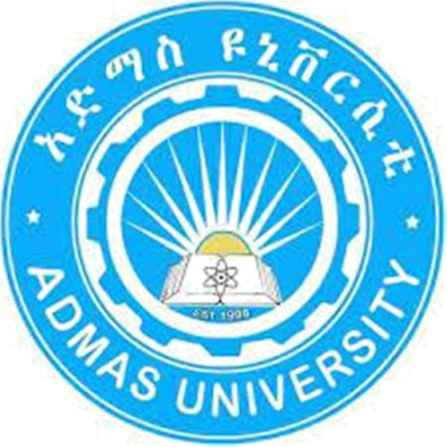

ADMAS UNIVERSITY

FACULTY OF INFORMATICS

DEPARTMENT OF COMPUTER SCIENCE

HISTORY OF ETHIOPIA AND THE HORN GROUP

ASSIGNMENT-2

Name | ID. No.
1. Abreham Mirgeza | 0891/19
2. Biruk Taye | 1468/19
3. Mesert Gonche | 1173/19
4. Million Mulugeta | 0754/19
5. Yosef Derirsa | 0896/19
6. Zelalem Yiheyis | 0748/19

Submitted to: Mr. Hassen

Submission Date: Thursday, 04 May, 2023
CHAPTER 2 QUESTIONS

- Describe Non-Muslim Non-Christian Traditions among the Cushitic groups (3 lines each).

  - Oromo:

Waaqeffannaa: This is a traditional religion that worships a single god. It is a monotheistic religion that emphasizes the importance of harmony with nature and respect for all living beings.
Irreecha: This is a thanksgiving ceremony that is held annually to celebrate the end of the rainy season and the beginning of the harvest season.

Gada system: This is a traditional system of governance that is based on age-sets. It is a democratic system where leaders are elected based on their age and experience.
  - Kambata:

Enset culture: Enset is a staple food crop that is unique to the Kambata region. It is used to make various dishes, including bread, porridge, and beer.

Gamo-Karo: This is a traditional dance that is performed by the Kambata people. It is a form of storytelling that uses dance and music to convey messages about history, culture and social issues. Bull jumping: This is a rite of passage for young men in the Kambata community. It involves jumping over a line of bulls to prove their bravery and strength.
  - Kaficho:

Gamo-Gofa: This is a traditional dance that is performed by the Kaficho people. It is a form of storytelling that uses dance and music to convey messages about history, culture and social issues.

Waaqeffannaa: Like the Oromo, the Kaficho people also practice the traditional religion of Waaqeffannaa. It is a monotheistic religion with nature and respect for all living beings.

Buna ceremony: Buna is a traditional coffee ceremony that is an important part of Kaficho culture. It involves roasting, grinding, and brewing coffee beans, and serving the coffee to guests.

CHAPTER 5 QUESTIONS (Page 94-97)

- Discuss the socio-cultural organizations of the people’s and states of South and South West (4 lines each).

A. Sidama: The Sidama had an indigenous system of governance led by the Mote (king). The Mote exercised political and administrative authority in consultation with the council of elders called Songo. The cultural and ritual leader in Sidama society was the Woma.

B. Gedeo: The dominant tradition relates the ancestors of the Gedeo to Daraso, who was the older brother of Gujo (father of Guji Oromo). The Gedeo had a culture called baalle, a traditional governance system that worked with age classes and ranking.

C. Konso: The name Konso is invariably used to refer one of the ancient peoples in Ethiopia and the Horn who spoke affa Konso (Konso language) and their land. The literal meaning of the term is a “heavily forested hill/area.

CHAPTER 5 QUESTIONS (Page 97-102)

3. People’s and States in South West Ethiopia (4 lines each)

A. Kaffa: Kaffa’s economy was based on the cultivation of enset on peasant farms supported by trade. Peasants rendered free labor service

and tilled royal estates with the support of slaves who were acquired through raiding or trading, or as payment for debt.

B. Yem: The Yem state was located along the eastern banks of the Gibe or to the northeast of the Kafa kingdom. Yem’s economy combined agriculture, trade and crafts. Initially, an indigenous dynasty called Dida or Halmam-Gamma ruled Yem from its palace in Dudarkema/Zimarma.

C. Gamo: Historically, the Gamo inhabited areas from Lakes Chamo and Abaya to the Gughe Mountain and beyond. The highlands were densely populated to people who escaped coercion by the state. A set of interrelated indigenous laws called the Woga.

D. Dawaro: Dawaro’s topography mostly is mountainous and plateau at the central, and lowland and plain at Gojeband Omoriver basins. The land is divided into three climatic zones. These are geziya (highland), dashuwa (mid-altitude) and gad’a (lowland).

E. Wolayta: The name Wolayta denotes a specific ethnic group in southwestern Ethiopia and their powerful kingdom, According to local traditions, before the emergence of Wolayta as a political unit, the area was inhabited by different communities such as the Badia, and Aruja.

CHAPTER 5 QUESTIONS (Page 102-104)

4. People’s and States of Western Ethiopia (3 lines each)

A. Berta-Gumuz: The Berta people inhabit the present Beni-Shangul Regional State. The Berta people speak the Berta language as their mother tongue.

B. Nuer: lived in areas that extended across the savannas and marshes of the Bahr el-Ghazal regions of the Sudan. They had been largely settled in the plains of Gambella along Sobat and Baro Rivers.

C. Majang: The Majang formed the southern end of the Nilo-Saharan settlement to the Baro plains. Linguistic evidence relates the origin of the Majang to the Boma plateau in South Sudan.

D. Kunama: People also called the Baza are the Western Eritrea on the Gash and Tekkeze Rivers and in Northwestern and Western Tigray.

